Friends of the CCLS LIbrary Meeting | Location: | Mont Belvieu Library
 | Date: | 2/20/24
 | Time: | 6:00 p.m.
 | Facilitator: | Molly McGinty

- Call to order
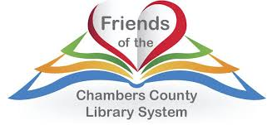
Welcome!
Introductions
Review of Agenda
- Officers & Elections
- President: Susanne Bogan (resigned in January 2024)
- Immediate Past President: Jean Abshier Forrest
- Vice-President: Elaine Byrd
- Treasurer: A. Lynette Parsons (resigned in December 2023)
- Executive Board members: Vickey Gaulding & Lena Yepez
- A big thank you to Susanne Bogan and Lynette Parsons for their time spent serving the CCLS Friends of the Library.

- Offices needed: President, Treasurer, Secretary

- Other officers? Do we have one representative of the three parts of the county (as stated in the By-Laws)
- Treasurer Report & Vote to open a bank account.
Let’s look at the Treasurer’s Report
A bank account at the First Bank of Anahuac needs to be opened. We can open 2-3 accounts.
- Money received from Donations/Book Sales/Laminations/etc.
- Grants/Nerd Con/SRP
- Nerd Con HOT Funds
- Allocate money for 2024 Summer Reading Program (SRP)
We are asking the Friends to donate $300 dollars to help with the summer reading program.
- Fundraiser Ideas
- Other Business
- Conclusion

